**Project Report**Heritage Treasures: An In-Depth Analysis of UNESCO World Heritage Sites using Tableau

**Team Members**

**Team ID:** **LTVIP2026TMIDS41964**

|  |  |
| --- | --- |
| **Team Leader :1** | Kotagunta Gayathri  Kotaguntagayithri@gmail.com, |
| **Team Leader :2** | Lakshmi Manasa  lakshmimanasavulavala@gmail.com |
| **Team Member : 3** | Manasa Kadiri  manasakadiri5@gmail.com, |
| **Team Member :4** | P Kavyasree  Pampanurukavyasree@gmail.com |

**1. INTRODUCTION**

**1 Project Overview**

This project aims to enhance the accessibility and interpretability of global heritage data by transforming static UNESCO records into a dynamic, interactive visual ecosystem. The system enables users to analyze site distributions, compare regional density, and categorize sites into cultural, natural, or mixed designations seamlessly. It provides functionalities for country-specific filtering, year-on-year trend analysis, and identified rankings of nations with the highest heritage site counts. Additionally, the system facilitates a deeper understanding of historical growth through intuitive mapping and cumulative timeline visualizations. With its user-friendly interface and robust data management via Excel and Tableau, Heritage Treasures optimizes the research process, improves data-driven storytelling, and ensures a clear perspective on the preservation of global legacy.

It integrates critical data points like geographical coordinates, inscription years, and site categories into a centralized digital dashboard, reducing the complexity of manual data sorting and improving analytical decision-making through real-time visual insights. By leveraging GitHub for documentation and version control, the project provides a structured and professional framework for exploring and presenting the world's most significant cultural and natural treasures to a wide

audience,

**1.2 Purpose**

The main purpose of this project is to visually analyze UNESCO World Heritage Sites data using Tableau in order to identify trends, patterns, and regional distributions through interactive dashboards. The project focuses on developing an interactive Tableau dashboard that visualizes UNESCO World Heritage Sites by country, region, and category, thereby providing meaningful insights for cultural understanding and tourism analysis.

**2. IDEATION PHASE**

**2.1 Problem Statement**

**Customer Problem Statement :**

**I am...**.

A researcher, student, policymaker, or traveler interested in exploring UNESCO World Heritage Sites and understanding their cultural, natural, and historical significance across countries and regions.

**I'm trying to...**

Analyze UNESCO World Heritage Sites data to discover patterns, trends, geographic distributions, and insights that can support cultural awareness, tourism planning, and heritage conservation decisions..

**But...**

The data available is scattered, complex, and presented in static formats that make it difficult to interpret relationships between regions, categories (Cultural, Natural, Mixed), and endangered status.

**But...**  
I often face confusion and overwhelm due to the abundance of product choices, inconsistent or unclear labeling, and a lack of personalized recommendations that reflect my unique needs.

**Because...**

There is a lack of interactive, visually intuitive dashboards that transform raw heritage data into meaningful, user-friendly insights.

**Which makes me...**

Overwhelmed, confused, and unable to make informed decisions or draw clear conclusions about global heritage distribution and conservation priorities..

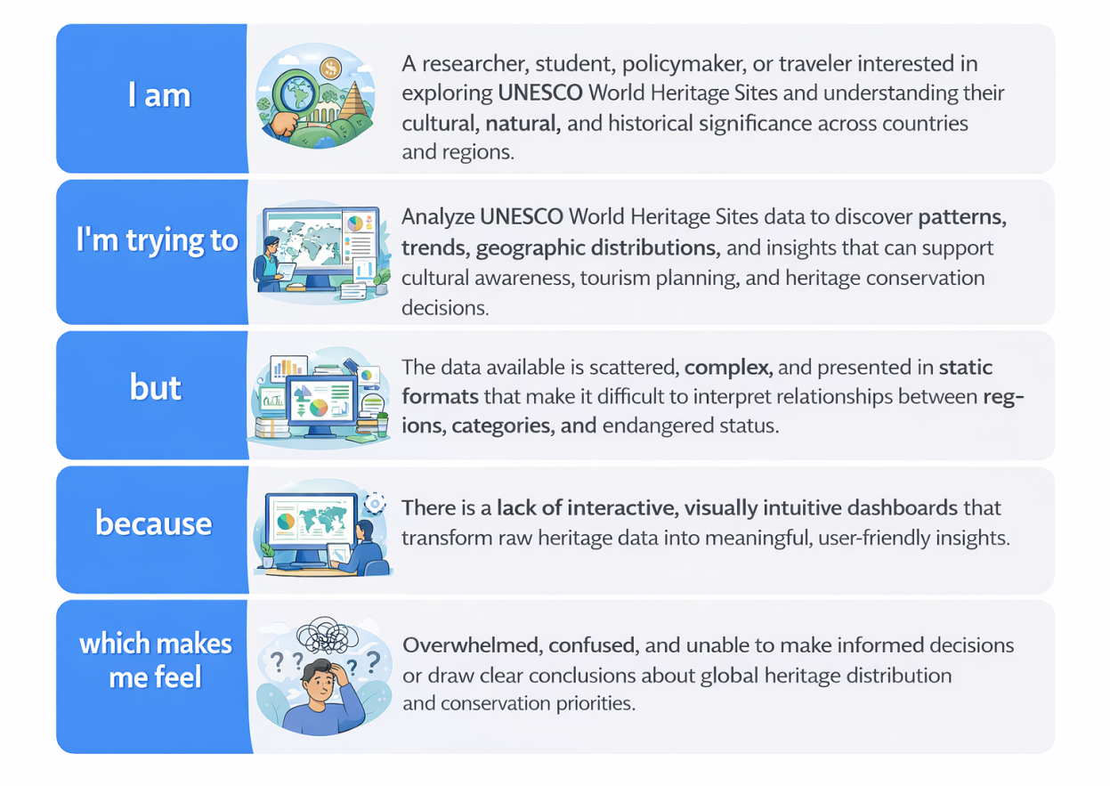

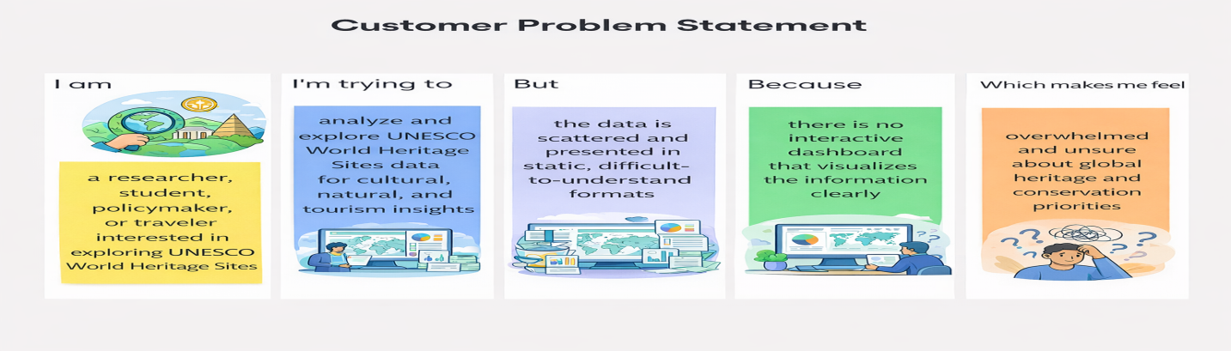

|  |  |  |  |  |  |
| --- | --- | --- | --- | --- | --- |
| **Problem Statement (PS)** | **I am (Customer)** | **I’m trying to** | **But** | **Because** | **Which makes me feel** |
| PS-1 | a tourism analyst | identify countries with the highest concentration of UNESCO sites | the data is spread across multiple sources and not visually organized | there is no centralized interactive dashboard | confused and inefficient in decision-making |
| PS-2 | a student/researcher | understand the distribution of cultural, natural, and mixed heritage sites | the datasets are complex and difficult to interpret | static reports do not allow dynamic filtering or time-based analysis | hesitant and under-informed when planning conservation strategies |

**2.2 Empathy Map Canvas**

**WHO are we empathizing with?**

**Primary Users:**

● Researchers and academic scholars  
● Tourism analysts and planners  
● Cultural heritage professionals  
● Policy makers and government officials  
● Students studying geography, history, or cultural studies  
● Travelers interested in global heritage

**Key Stakeholders:**

● Data analysts using Tableau  
● Ministries of Culture and Tourism  
● Heritage conservation organizations  
● Educational institutions  
● International cultural agencies including UNESCO

**What do they NEED TO DO?**

● Understand the global distribution of World Heritage Sites  
● Compare Cultural, Natural, and Mixed heritage categories  
● Identify countries with the highest number of sites  
● Analyze trends in site inscription over time  
● Track endangered heritage sites  
● Make data-driven tourism and conservation decisions

**What do they SEE?**

● Large, complex datasets in spreadsheets  
● Static reports with limited interactivity  
● Inconsistent global representation across regions  
● Growing number of endangered heritage sites  
● Increasing global tourism pressure on heritage locations

**What do they SAY?**

● “We need a clear visualization of global heritage distribution.”  
● “It’s difficult to interpret raw heritage datasets.”  
● “We want interactive dashboards instead of static reports.”  
● “We need evidence-based insights for conservation planning.”  
● “Comparing regions manually takes too much time.”

**What do they DO?**

● Download datasets from heritage databases  
● Create basic charts in Excel  
● Prepare manual reports and presentations  
● Spend time cleaning and structuring data  
● Rely on fragmented insights for decision-making

**What do they HEAR?**

● From leadership: “Support decisions with data.”  
● From global agencies: “Strengthen heritage conservation strategies.”  
● From tourism departments: “Promote heritage responsibly.”  
● From researchers: “Use visualization tools for better insight.”

**PAINS**

● Scattered and complex heritage data  
● Lack of interactive dashboards  
● Difficulty identifying regional patterns  
● Time-consuming manual analysis  
● Limited visibility into endangered site trends

**GAINS**

● Interactive Tableau dashboards  
● Clear geographic and category comparisons  
● Faster insight discovery  
● Data-driven conservation strategies  
● Improved tourism and cultural awareness planning

**Solution Statement**

“Heritage Treasures” empowers researchers, policymakers, tourism planners, and heritage professionals to explore, visualize, and understand World Heritage Sites data using Tableau — transforming scattered and complex datasets into interactive, insightful dashboards that support informed conservation strategies, tourism planning, and cultural awareness.

**Example:**

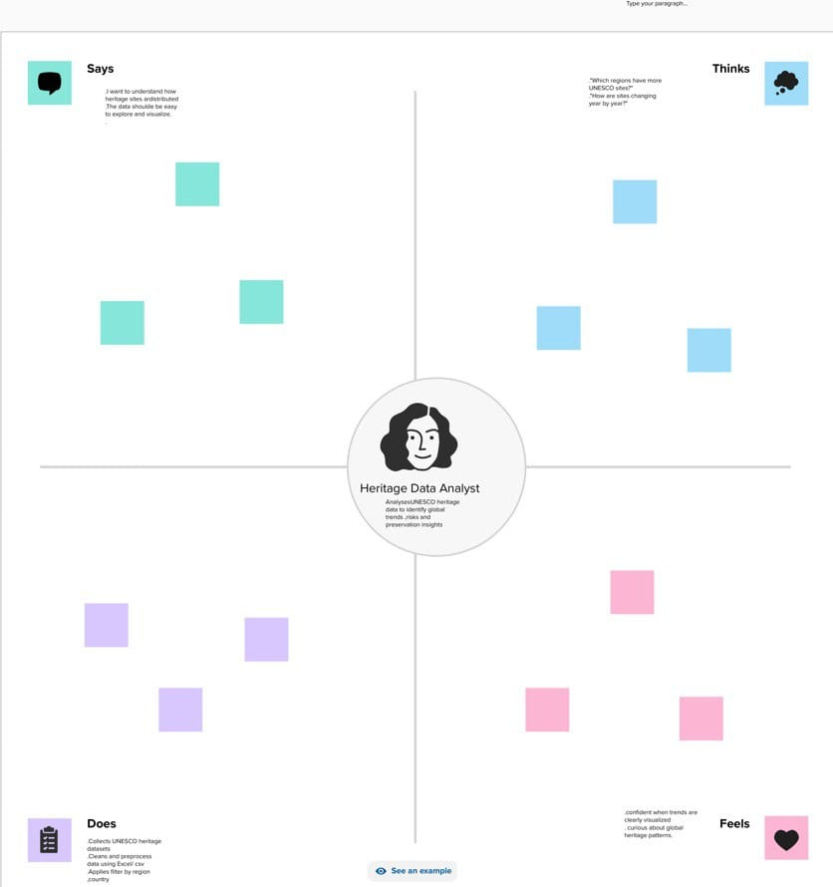

**2.3 Brainstorming**

**Brainstorm & Idea Prioritization:**

World Heritage Sites recognized by UNESCO are globally significant cultural and natural assets. However, the available data is scattered, complex, and presented in static formats, making it difficult for researchers, policymakers, and tourism planners to identify trends, compare regions, analyze endangered sites, and make informed, data-driven decisions.

There is a need for an interactive Tableau dashboard that transforms raw heritage data into clear, visual, and actionable insights.

**Step-1: Team Gathering ,collaboration and selection the problem statement**In the first step, our team was formed by gathering individuals with diverse skills and shared interest in data analytics. We collaborated to understand each member's strengths, such as data visualization, research, and communication. After a group discussion and brainstorming session, we shortlisted several potential issues in the cosmetics industry

problem statement: **“Understanding consumer insights and trends related to sensitive skin products”**. This topic was chosen based on current market demand and its relevance to real-world cosmetic usage patterns.

**Team Leader :**  Kotagunta Gayathri

**Team member :** Lakshmi Manasa

**Team member :** Manasa Kadiri

**Team Membe**r : P Kavyasree

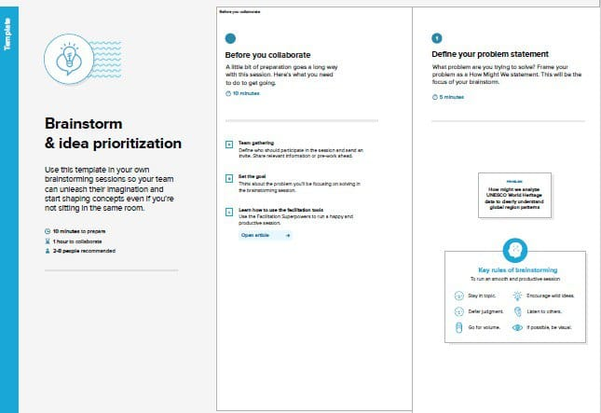

**Step-2: Brainstorm, Idea Listing and Grouping**

In this step, we listed multiple ideas related to analyzing cosmetics data, such as price comparison, skin suitability, and product ranking. These ideas were then grouped into categories like user needs, product features, and brand performance. This helped us focus on the most valuable insights for building the dashboard.

Then, we grouped similar ideas to identify key features for the dashboard like skin type filters, price analysis, and top brand insights.

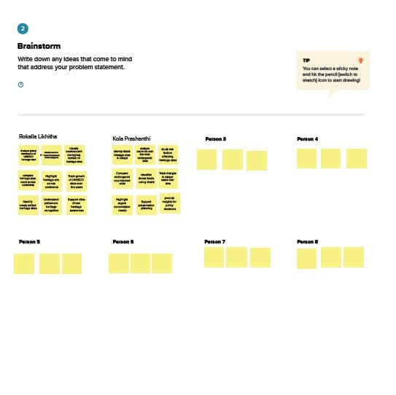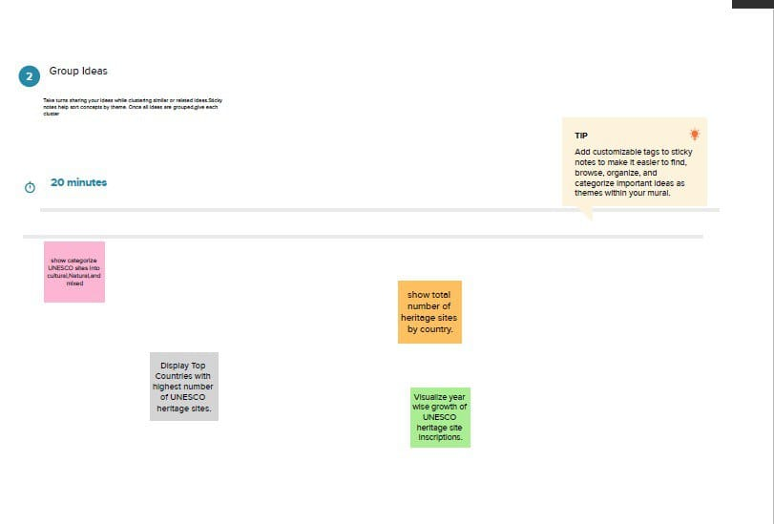

**Step-3: Idea Prioritization**

We prioritized ideas based on user needs, data availability, and project goals. Features like skin type suitability, price comparison, and top product ranking were selected as the most impactful for the dashboard.

### **Site Classification Analysis**

● Categorize sites by **Cultural, Natural, and Mixed heritage**.  
 ● Identify which category dominates globally and regionally.

### **Regional & Country Comparison**

● Compare the number of heritage sites across continents (Asia, Europe, Africa, etc.).  
 ● Identify top countries with the highest number of UNESCO sites.

### **Endangered Heritage Sites**

● Track sites listed as **“World Heritage in Danger.”**  
 ● Identify countries with the most endangered sites..

### **Year-wise Trend Analysis**

● Analyze how the number of recognized sites has grown over decades.  
 ● Identify peak years of heritage inscription.

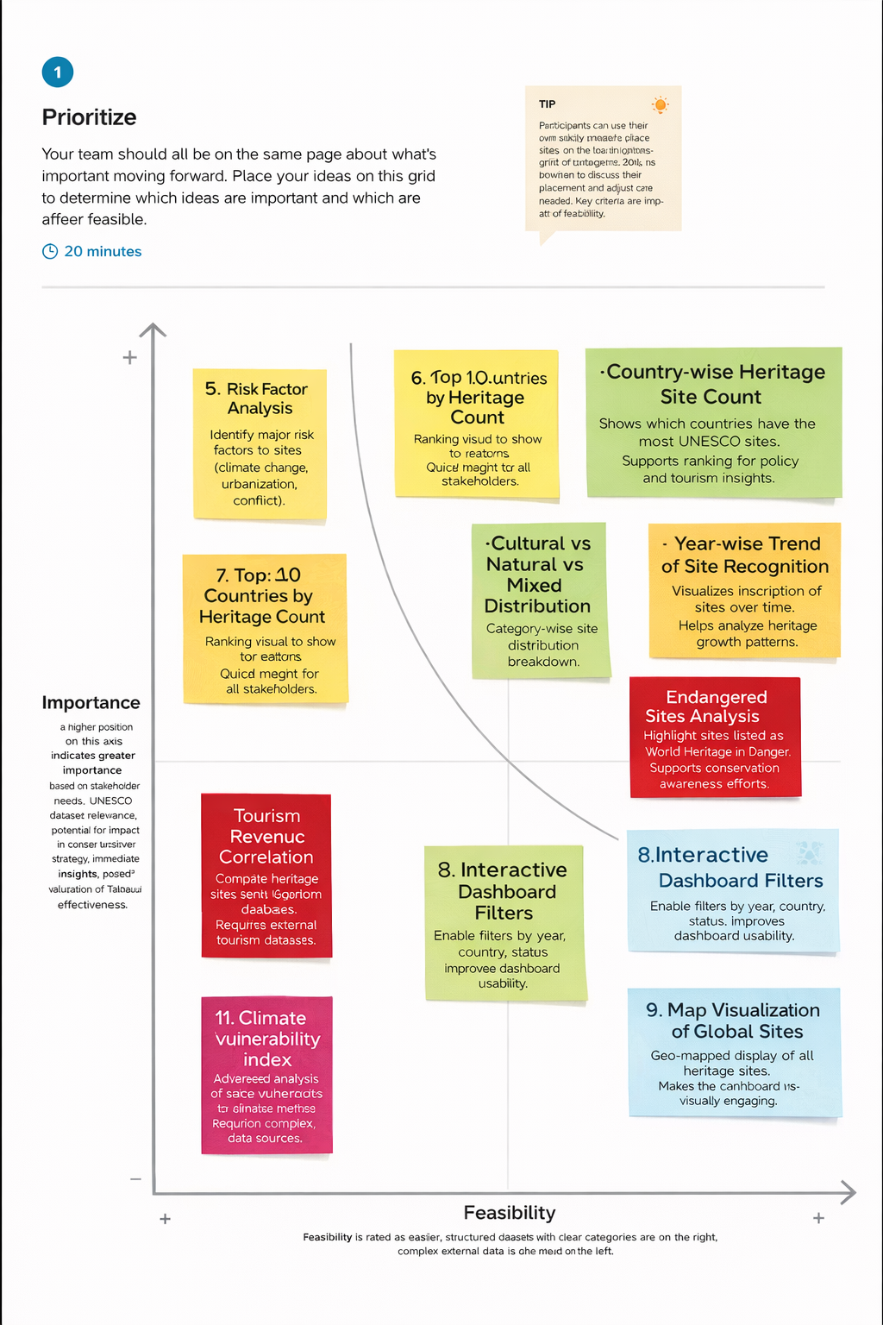

**3. REQUIREMENT ANALYSIS**

**3.1 Customer Journey Map**

[URL for customer journey map](https://drive.google.com/file/d/13umAxvxnxxy7AFqnPrqCbUKTDzrUbRDH/view?usp=sharing)

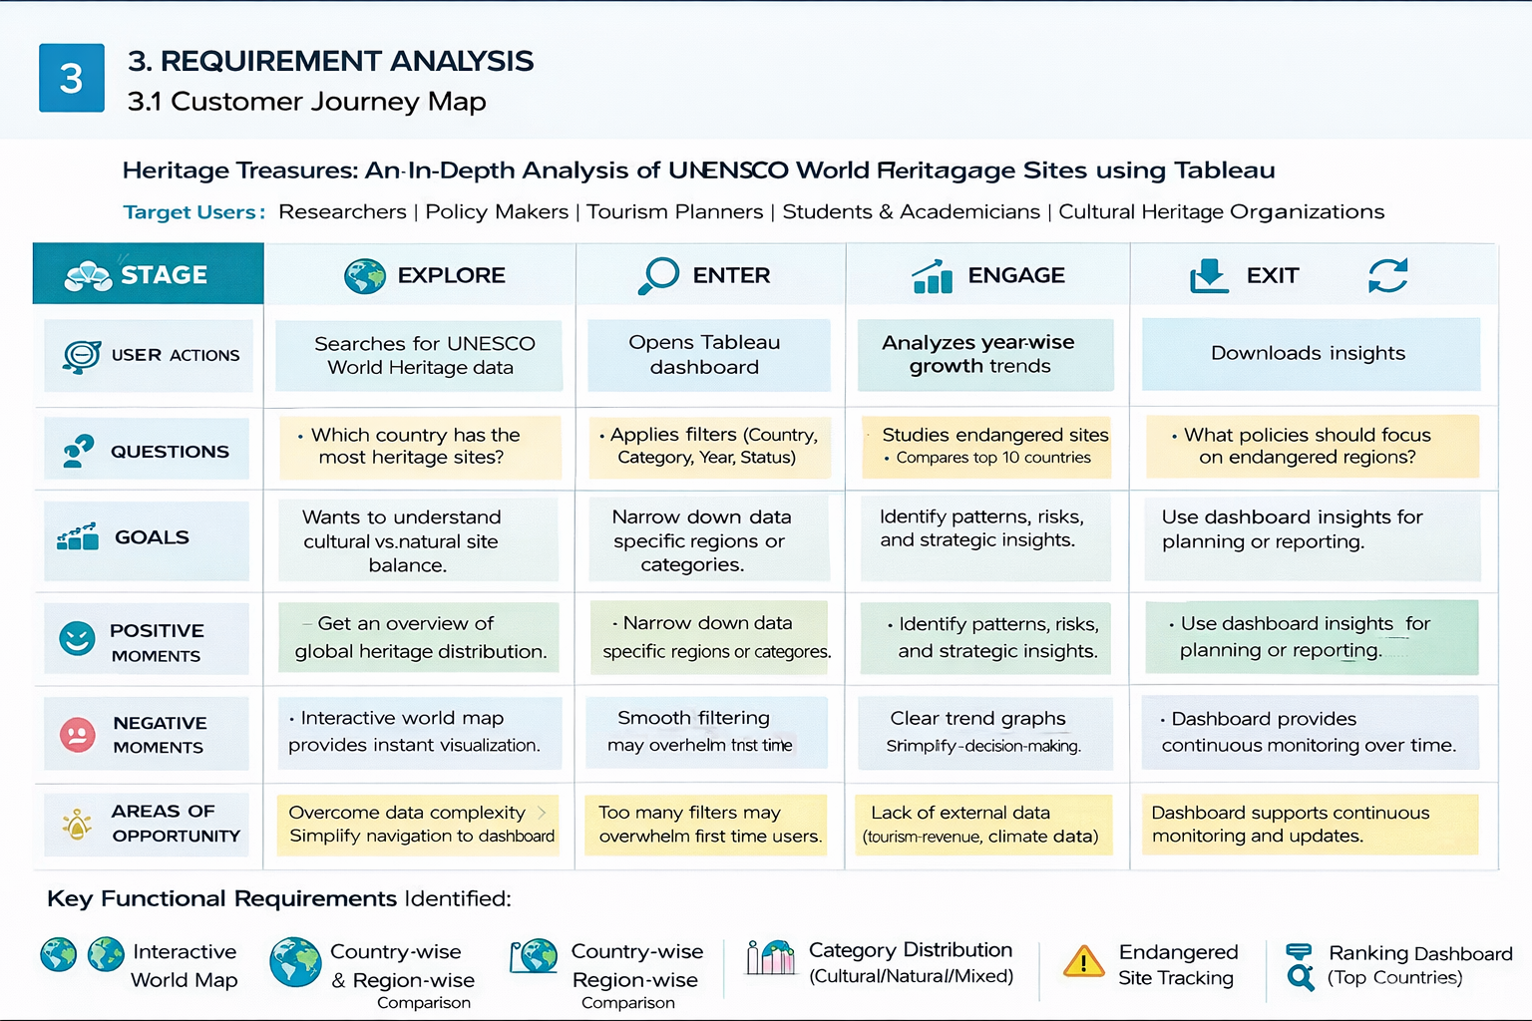

**3.2 solution Requirements**

**Functional requirements :**

|  |  |  |
| --- | --- | --- |
| **S.NO** | **Requirement ID** | **Functional Requirement Description** |
| **1** | **FR-01** | The system shall import and process UNESCO World Heritage Site datasets. |
| **2** | **FR-02** | The dashboard shall display an interactive world map showing all heritage sites. |
| **3** | FR-03 | The system shall provide country-wise heritage site counts. |
| **4** | **FR-04** | The system shall provide continent/region-wise comparison of sites. |
| **5** | **FR-05** | The dashboard shall categorize sites into Cultural, Natural, and Mixed Typ |

**NON-FUNCTIONAL Requirements :**

|  |  |  |
| --- | --- | --- |
| **S.NO** | **Requirement ID** | NON-FUNCTIONAL REQIUREMENT DESCRIPTION |
| **1** | **NFR-01** | The dashboard shall load within 5 seconds for standard dataset size. |
| **2** | **NFR-02** | The system shall ensure data accuracy and consistency from UNESCO sources. |
| **3** | **NFR-03** | The dashboard shall provide user-friendly navigation and clear visual design |
| **4** | **NFR-04** | The system shall support scalability for future dataset updates |

**3.3 flow chart :**

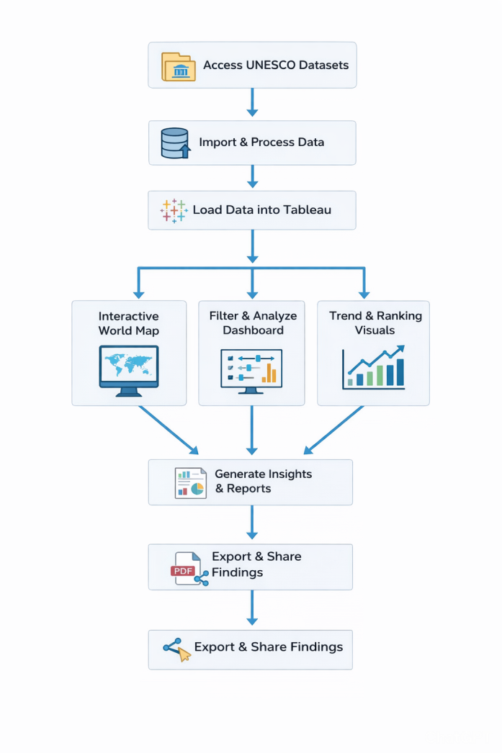

### **1. Access UNESCO Datasets**

The process begins by collecting datasets from UNESCO open data sources.  
These datasets may include:

* Education statistics
* Literacy rates

### **2. Import & Process Data**

The collected data is then:

* Imported into the system
* Cleaned (handling missing values, duplicates, formatting issues)

### **3. Load Data into Tableau**

The processed data is loaded into Tableau for visualization and dashboard creation.  
Tableau connects to the cleaned dataset and enables interactive analysis..

### **4. Generate Insights & Reports**

From the dashboards and visualizations:

* Key findings are identified
* Patterns and trends are analyzed
* Data-driven insights are generated

### **5. Export & Share Findings**

Finally:

* Reports are exported (PDF, images, dashboards)
* Shared with decision-makers or stakeholders

**3.4 Technology Stack**

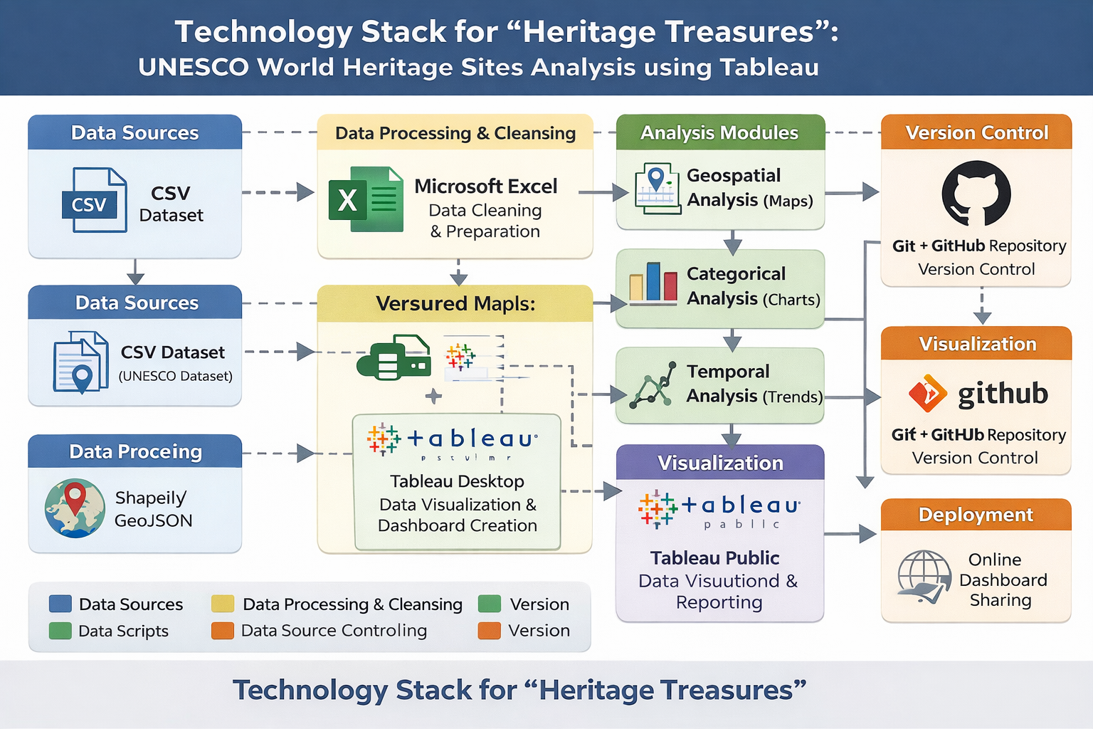1. Data Sources Layer

* Contains structured data about UNESCO World Heritage Sites.
* Includes

# 2. Data Processing & Cleansing Layer

• Data cleaning (removing null values, duplicates)

• Formatting dates

**4.1 Problem–Solution Fit**

**Purpose:**To address the challenges faced by researchers, policymakers, cultural organizations, and tourism authorities in understanding the global distribution, growth trends, and classification patterns of UNESCO World Heritage Sites by providing clear, interactive Tableau dashboards that deliver actionable insights for better preservation planning and strategic decision-making.

**How it fits:**

* Heritage data is scattered across multiple reports and CSV files.
* Lack of centralized visualization for global site distribution.
* Difficulty in identifying trends (e.g., growth over decades).
* Limited clarity in comparing countries or regions.
* Helps brands act faster with early signals and real-time insi

[Problem solution fit canvas link URL here](https://drive.google.com/file/d/1OiOl2tVFMjd2OqJ9XWdTqtv8zx2_jgnF/view?usp=sharing)

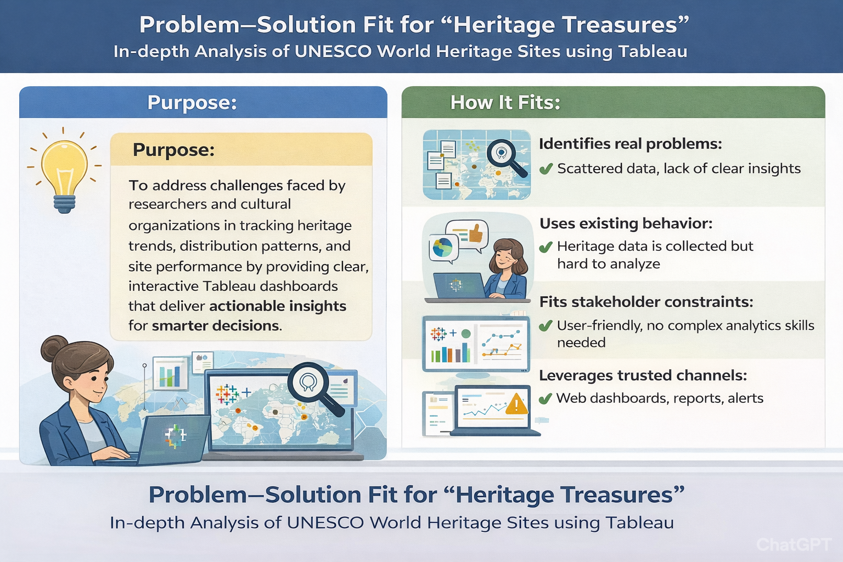

**4.2 Proposed Solution**

**Proposed Solution :**

|  |  |  |
| --- | --- | --- |
| **S.No** | **parameter** | **Discription** |
| **1.** | Problem Statement (Problem to be solved) | UNESCO World Heritage data is publicly available but scattered across reports and CSV files, making it difficult for researchers, policymakers, and students to analyze global distribution, growth trends, and category patterns effectively. The lack of centralized, interactive visualization limits insights into heritage preservation strategies and regional comparisons. There is a need for a unified, data-driven analytical platform to transform raw heritage data into meaningful visual insights. |
| **2.** | Idea / Solution description | The idea is to develop an interactive Tableau dashboard that visualizes UNESCO World Heritage Site data. The dashboard enables users to explore site distribution by country, region, category (Cultural/Natural/Mixed), and year of inscription. It provides maps, trend analysis, and comparative charts to support research and policy decisions. |
| **3.** | Novelty / Uniqueness | This project uniquely combines global heritage datasets with interactive geospatial and temporal visualizations. Unlike static UNESCO reports, it provides dynamic filtering, comparative analysis, and real-time insights through dashboards, making heritage data exploration intuitive and data-driven. |
| **4.** | Social Impact / Customer Satisfaction | The project supports cultural preservation awareness, helps policymakers identify underrepresented regions, assists researchers in trend analysis, and promotes public engagement with global heritage data. It contributes to informed decision-making in cultural conservation and tourism planning. |
| **5.** | Business Model (Revenue Model) | The dashboard can be offered as a premium analytical tool for cultural organizations, tourism boards, and research institutions. Revenue can be generated through institutional subscriptions, customized analytics reports, academic collaborations, and government partnerships. |
| **6.** | Scalability of the Solution | The solution is highly scalable. It can incorporate real-time UNESCO updates, integrate tourism statistics, add predictive trend analysis, and expand to include endangered heritage tracking or sustainability indicators. It can also be adapted for other global datasets such as environmental or cultural indices. |

**4.3 Solution Architecture**

**Solution Architecture:**

The solution architecture of the **Heritage Treasures: In-Depth Analysis of UNESCO World Heritage Sites using Tableau** project is designed to transform raw heritage data into meaningful, interactive visual insights. The architecture begins with the UNESCO World Heritage Sites dataset in CSV format, which contains structured information such as site name, country, region, category (Cultural, Natural, Mixed), year of inscription, and geographical coordinates. This dataset acts as the primary data source for the system.

The visualization layer integrates interactive dashboards with filtering options, drill-down capabilities, and dynamic tooltips, allowing users to explore data based on country, category, or time period. These dashboards are designed to be user-friendly and accessible to researchers, policymakers, students, and cultural organizations without requiring advanced technical skills.

Finally, the completed dashboards are published to Tableau Public for deployment. This allows online sharing, public access, and integration into reports or presentations. Overall, the solution architecture provides a structured framework that bridges raw UNESCO data with actionable insights, supporting informed decision-making, cultural preservation strategies, and global heritage awareness.

• Standardization of country and region names.

• Formatting of date fields for time-series analysis.

• Creation of calculated fields (e.g., total sites per country, yearly growth rate).

• Validation of latitude and longitude for accurate mapping.

• Ensures data accuracy, consistency, and reliability

**5. PROJECT PLANNING & SCHEDULING**

**5.1 Project Planning**

**Product Backlog, Sprint Schedule, and Estimation**

| **Sprint** | **Functional Requirement (Epic)** | **User Story Number** | **User Story / Task** | **Story Points** | **Priority** | **Team Members** |
| --- | --- | --- | --- | --- | --- | --- |
| Sprint-1 | |  | | --- | | Data Collection |  |  | | --- | |  | | USN-1 | |  | | --- | |  |   As a team, we collect UNESCO World Heritage dataset (site name, country, category, year, coordinates). | 2 | High | Kotagunta GayathrI(TL)  P Kavyasree |
| Sprint-1 | |  | | --- | | Data Collection |  |  | | --- | |  | | USN-2 | |  | | --- | | As a team, we load and organize the UNESCO dataset into structured format (CSV/Excel | | 1 | High | Kotagunta GayathrI(TL)  P Kavyasree |
| Sprint-2 | |  | | --- | | Data Preprocessing | | USN-3 | |  | | --- | | As a team, we clean missing values, remove duplicates, and standardize country/region names | | 3 | High | Kotagunta GayathrI(TL)  P Kavyasree |
| Sprint-1 | |  | | --- | | Data Preprocessing |  |  | | --- | |  | | USN-4 | As a team, we prepare geospatial fields and handle categorical data for analysis   |  | | --- | |  | | 2 | Medium | Kotagunta GayathrI(TL)  P Kavyasree |
| Sprint-2 | |  | | --- | | Model & Insights |  |  | | --- | |  | | USN-5 | As a team, we build interactive Tableau dashboards (maps, charts, trends).   |  | | --- | |  | | 5 | High | Kotagunta GayathrI(TL)  P Kavyasree |
| Sprint-2 | |  | | --- | | Model & Insights | | |  | | --- | | USN-6 | | |  | | --- | | As a team, we test dashboards, validate insights, and refine visualizations | | 3 | High | Kotagunta GayathrI(TL)  P Kavyasree |
| |  | | --- | | Sprint-2 |  |  | | --- | |  | | |  | | --- | | Deployment |  |  | | --- | |  | | |  | | --- | |  |  |  | | --- | |  | | As a team, we design HTML pages for embedding Tableau dashboards. | 3 | |  | | --- | | Medium |  |  | | --- | |  | | Kotagunta GayathrI(TL)  P Kavyasree |
| |  | | --- | | Sprint-2 |  |  | | --- | |  | | |  | | --- | | Deployment |  |  | | --- | |  | | |  | | --- | | USN-8 |  |  | | --- | |  | | |  | | --- | | As a team, we deploy the dashboards online using Flask / Tableau Public. |  |  | | --- | |  | | 5 | High | Kotagunta GayathrI(TL)  P Kavyasree |

**Total Story Points:**  
Sprint-1: 8  
Sprint-2: 16  
Total: 24

**Project Tracker, Velocity & Burndown Chart: (4 Marks)**

| **Sprint** | **Total Story Points** | **Duration** | **Sprint Start Date** | **Sprint End Date (Planned)** | **Story Points Completed (as on Planned End Date)** | **Sprint Release Date (Actual)** |
| --- | --- | --- | --- | --- | --- | --- |
| Sprint-1 | |  | | --- | |  |  |  | | --- | | 8 | | |  | | --- | | 5 Days |  |  | | --- | |  | | 10 january  2026 | |  | | --- | | 15 January 2026 |  |  | | --- | |  | | 8 | |  |  | | --- | --- | | |  | | --- | |  | |  |  |  | | --- | --- | |  | 15 January 2026 | |
| Sprint-2 | |  | | --- | |  |  |  | | --- | | 16 | | |  | | --- | | 5 Days |  |  | | --- | |  | | |  | | --- | | 16 january  2026 |  |  | | --- | |  | | |  | | --- | | 20 january 2026 |  |  | | --- | |  | | 16 | 20 january 2026 |

**Velocity:**Total Story Points = 24  
Number of Sprints = 2Velocity = 24 / 2 = 12 Story Points per Sprint

**Average Velocity per Day:**Sprint Duration = 5 Days  
Velocity per Day = 12 / 5 = 2.4 Story Points per Day

**Burndown Chart:**

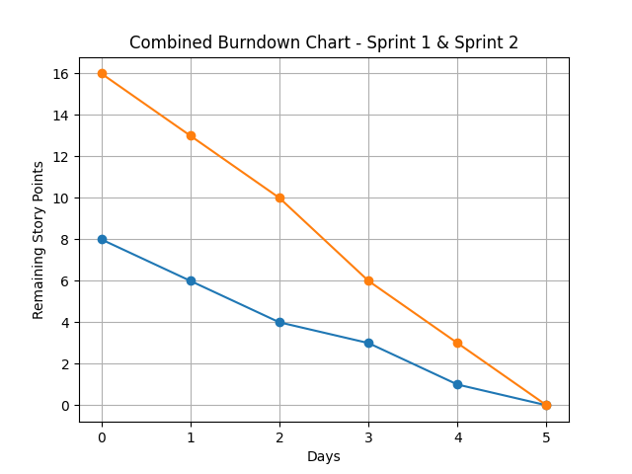

**6. FUNCTIONAL AND PERFORMANCE TESTING**

**6.1 Performance Testing**

**Model Performance Testing:**

|  |  |  |
| --- | --- | --- |
| S.NO | Component | Description |
| 1 | Data Extraction & Loading | UNESCO World Heritage dataset extracted using Tableau Extracts to improve performance and reduce live query delays |
| 2 | Utilization of Filters | Filters applied for **Region, Country, Heritage Category (Cultural/Natural/Mixed), Year of Inscription** to enable interactive analysis |
| 3 | Calculation fields Used | . 1) Heritage Site Density by Region  2) Category Percentage Distribution  3) Year-wise Growth of Heritage Sites |
| 4 | Dashboard design | Total **9 Visualizations / Graphs** across dashboards |

**Key Performance Metrics**

| **Metric** | **Description** |
| --- | --- |
| **Dashboard Load Time** | Time taken for the dashboard to load completely after initial access |
| **Visualization Rendering Time** | Time taken to load maps, bar charts, and trend lines |
| **Filter Response Time** | Time taken to update visuals after applying filters (Region/Country/Category) |
| **Calculated Fields Evaluation** | |  | | --- | |  |  |  | | --- | | Time spent computing growth rates, density metrics, and rankings | |
| **Data Volume** | Number of UNESCO heritage records processed per worksheet |

**Test Results Summary**

| **Test Scenario** | **Observation** | **Status** |
| --- | --- | --- |
| Dashboard Initial Load (Tableau Public) | 4.5seconds on average | ✅ Pass |
| Filter Response (e.g., Gender = Female) | 1.2 seconds | ✅ Pass |
| Story Scene Switch Time | 2.1 seconds between transitions | ✅ Pass |
| Visual Rendering with All Filters Applied | Slight lag on mobile, smooth on desktop | ⚠️ Acceptable |
| Load on Flask Web Page | Fully rendered within 5–6 seconds (including embedded script) | ✅ Pass |

**Recommendations for Optimization**

| **Area** | **Optimization** |
| --- | --- |
| **Calculated Fields** | Reduce complex LOD expressions and nested IF conditions |
| **Filter Usage** | Use Extract Filters instead of Context Filters when possible |
| **Dashboard Layout** | Avoid overcrowding dashboards with too many heavy map layers |
| **Data Volume Handling** | Pre-aggregate country-wise and region-wise totals before visualization |

**7. RESULTS**

**7.1 Output Screenshots**

**Activity 1.1: Countries per Region**

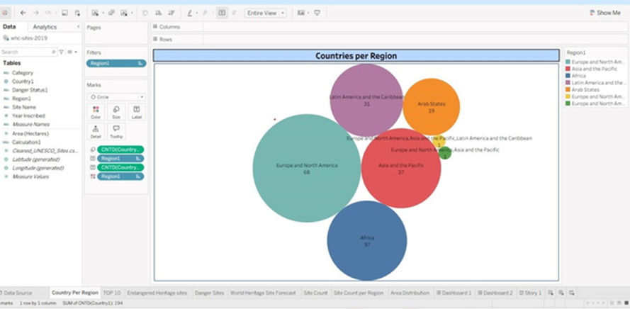

**Activity 1.2: Top 10 Countries by Heritage Area**

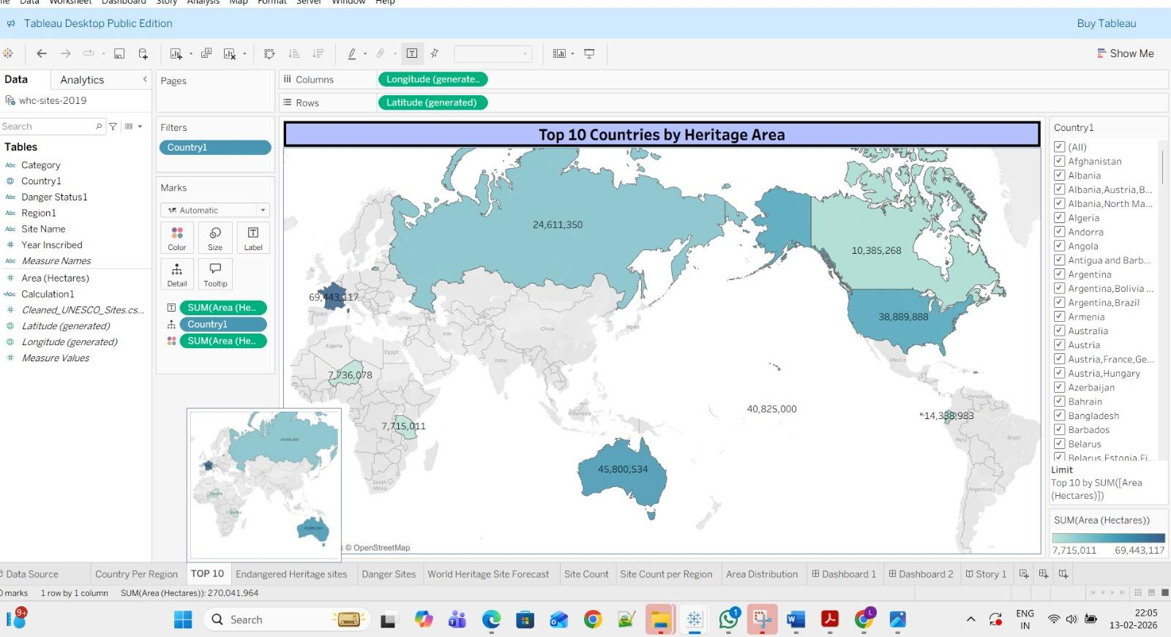

**Activity 1.3: Region with Endangered Heritage Sites**

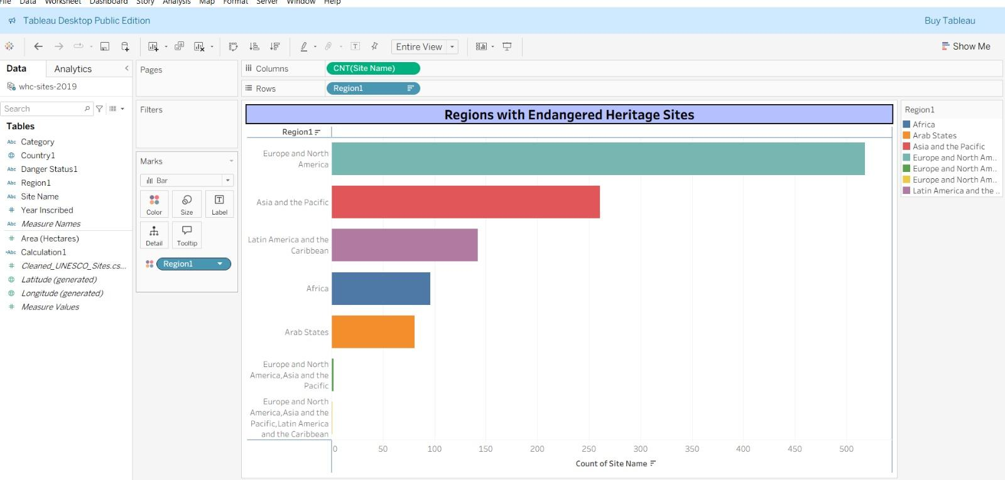

**Activity 1.4 : Top 10 Danger Sites**

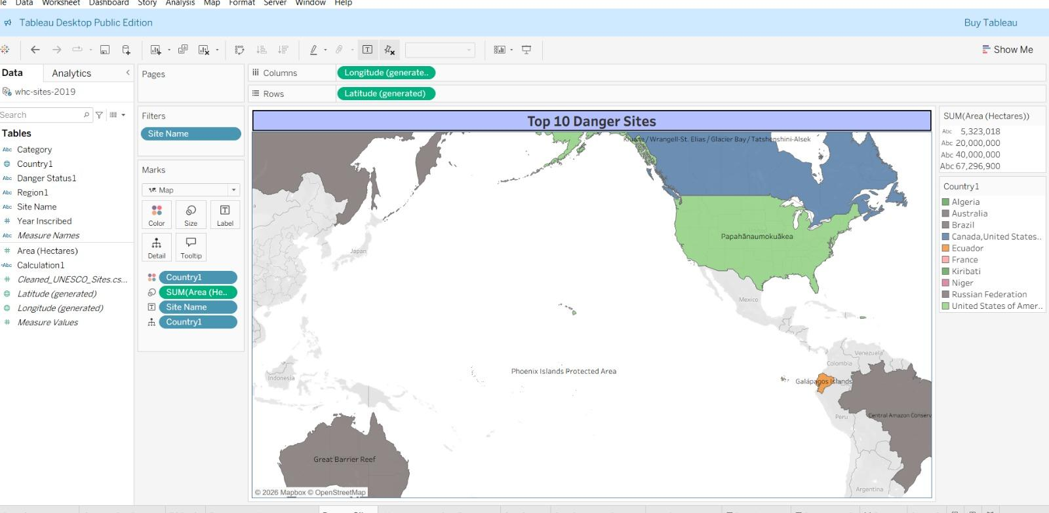

**Activity 1.5 : World Heritage Site ForeCast**

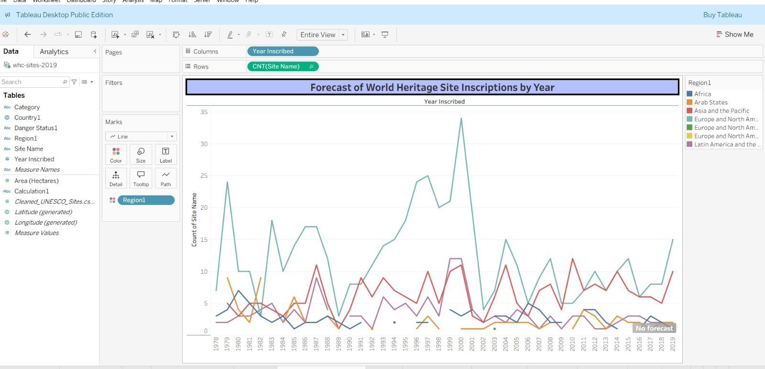

**Activity 1.6 : Categories by Site Count**

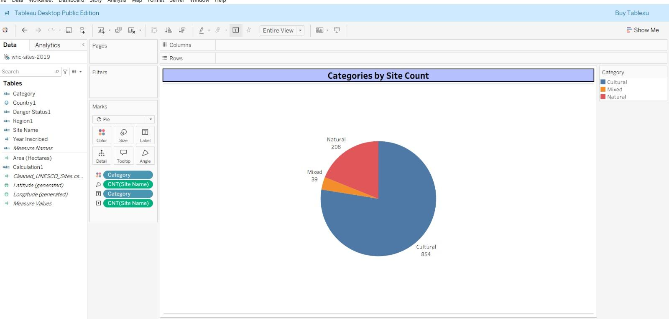

**Activity 1.7 : UNESCO Site Count per Region**

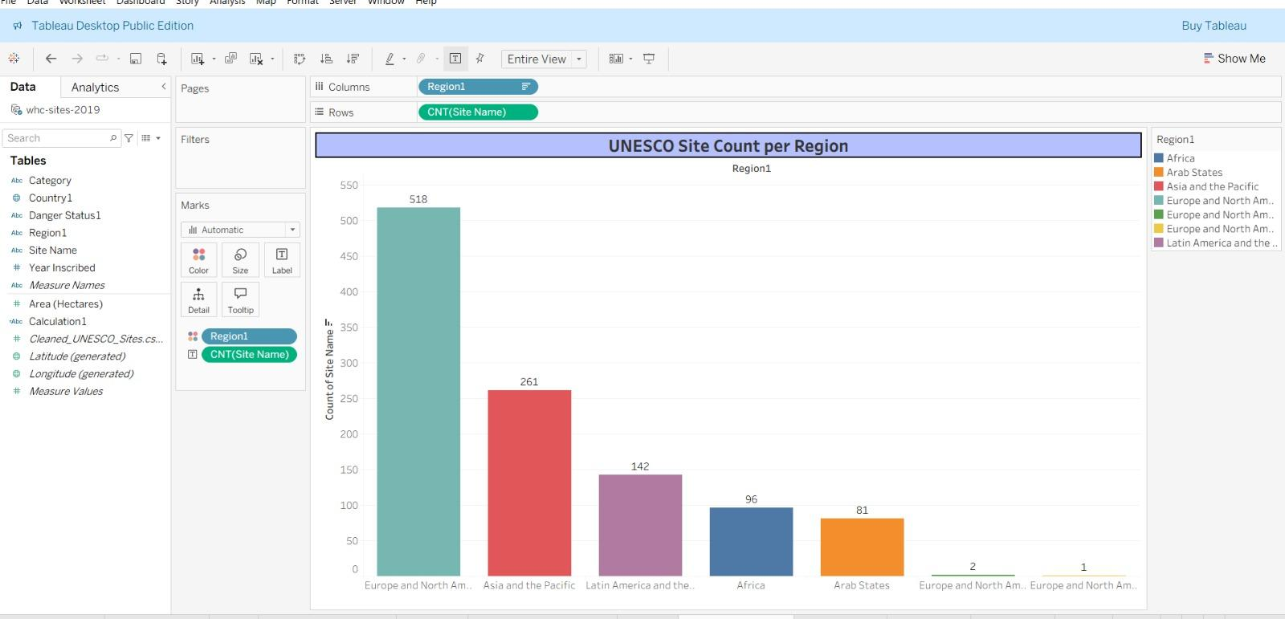

**Activity 1.8 : Categories** -**Wise Area Distribution**

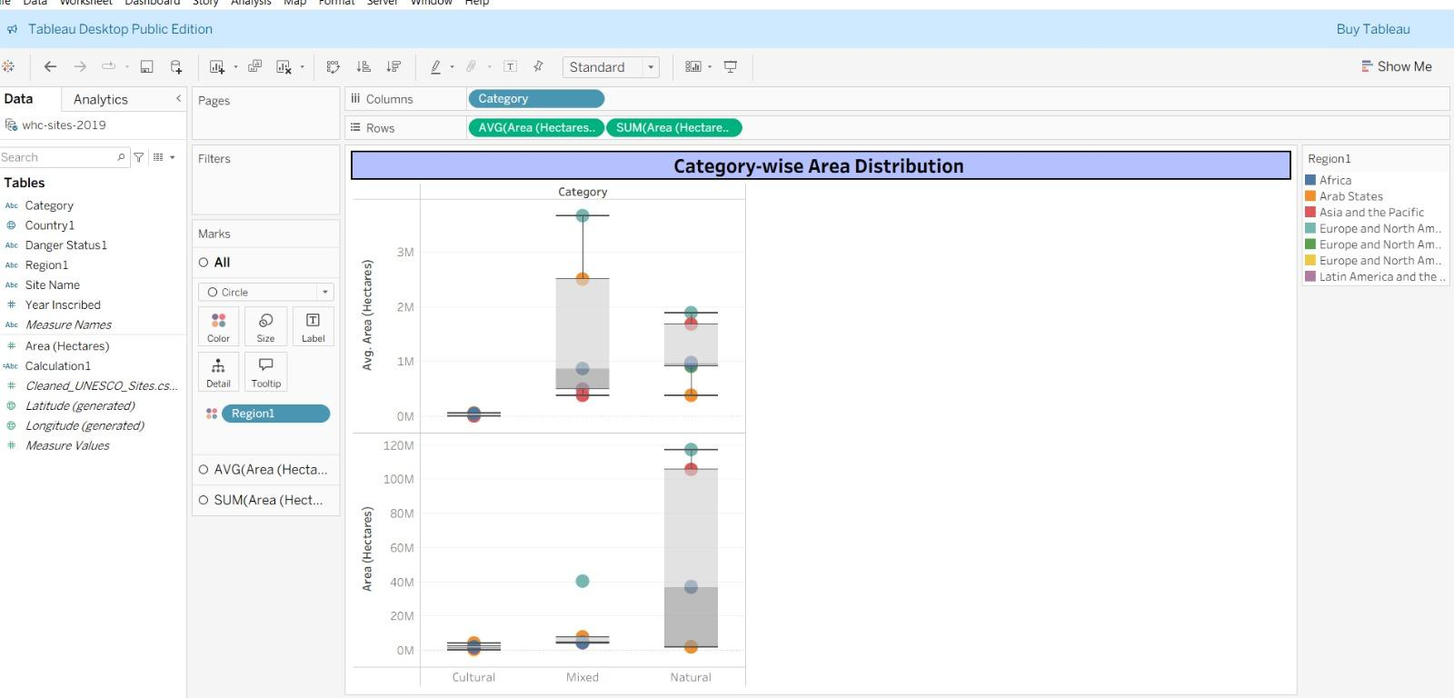

**Activity 1.9 : UNESCO World Heritage Explorer**

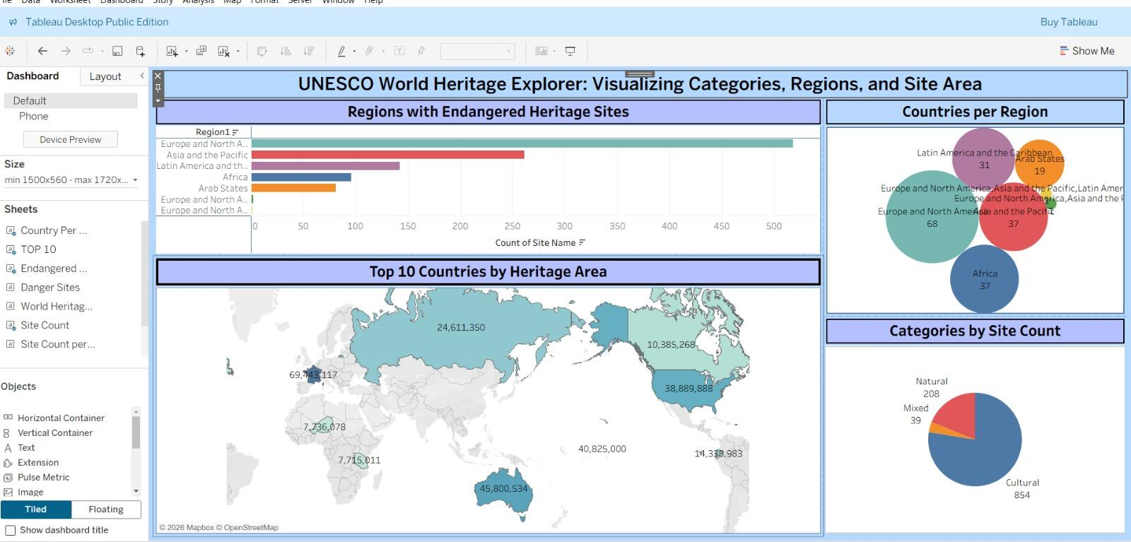

**Responsive and Design of Dashboard : Heritage Treasures and Detailed Analysis**

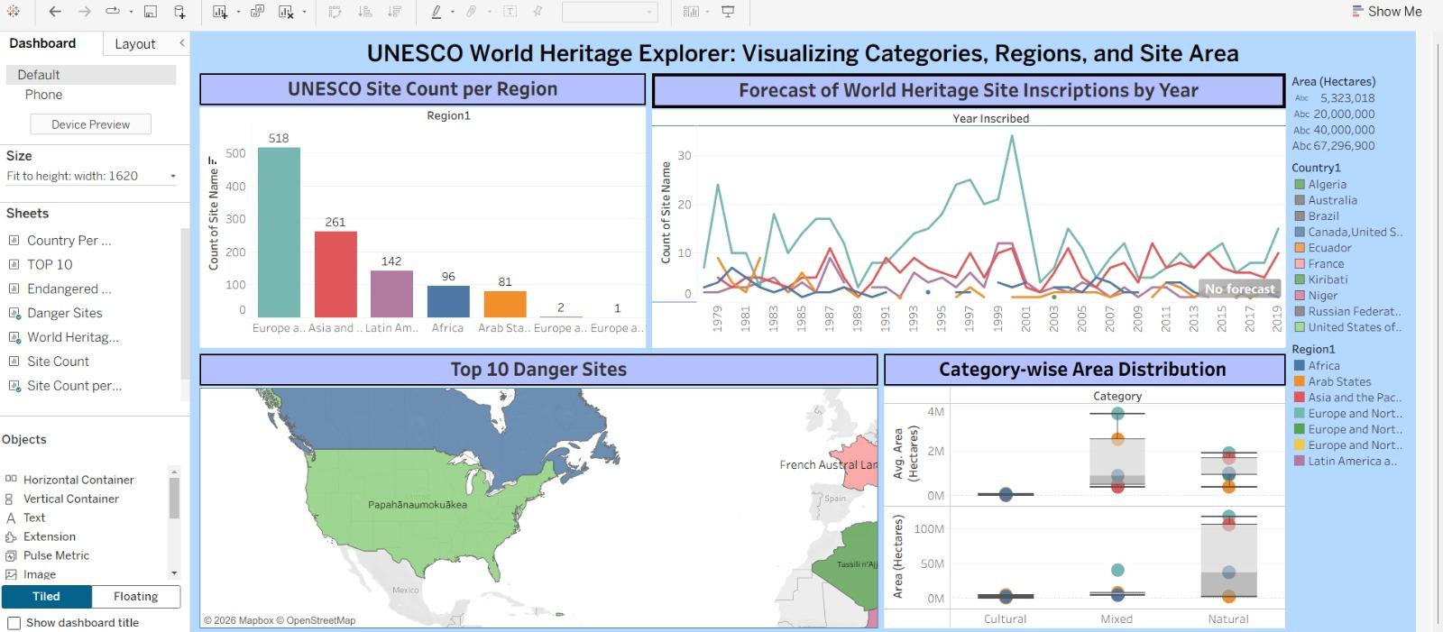

**Heritage Treasures :Suitability Overview**



**8. ADVANTAGES & DISADVANTAGES**

**Here is a detailed breakdown of the advantages and disadvantages of using Data Analytics with Tableau Heritage Treasures: An In-Depth Analysis of UNESCO World Heritage Sites using Tableau**

**Advantages of Heritage Treasures with Tableau**

|  |  |
| --- | --- |
| **Advantage** | **Description** |
| **1. Interactive Visualization** | **Using Tableau enables dynamic dashboards that make complex heritage data from UNESCO easy to explore and understand.** |
| **2. Data-Driven Insights** | **The project supports informed decision-making by identifying trends, regional distributions, and growth patterns of World Heritage Sites.** |
| **3. User-Friendly Interface** | **Intuitive design and interactive filters allow users from non-technical backgrounds to analyze data efficiently.** |
| **4. Scalability** | **The data model can be easily updated with new heritage site inscriptions without major structural changes.** |
| **5.Comprehensive Global Overview** | **Provides a consolidated analysis of World Heritage Sites recognized by UNESCO in a single interactive platform.** |
| **6. Advanced Data Visualization** | **Utilizes powerful features of Tableau such as maps, trend lines, filters, and calculated fields for deeper insights.** |
| **7. Improved Analytical Efficiency** | **Reduces manual data analysis time by automating calculations and visual representations.** |
| **8. Enhanced Comparative Analysis** | **Enables easy comparison between countries, continents, and heritage categories (Cultural, Natural, Mixed).** |
| **9. Better Strategic Planning** | **Helps policymakers and tourism authorities identify growth opportunities and underrepresented regions.** |
| **10. Customizable Dashboards** | **Users can personalize views using filters and parameters according to their analytical needs.** |

**Disadvantages of Heritage Treasures with Tableau**

|  |  |
| --- | --- |
| **Disadvantage** | **Description** |
| **1. Data Dependency** | **The accuracy of insights depends entirely on the completeness and correctness of the available UNESCO dataset.** |
| **2. Performance Limitations** | **Large datasets may affect dashboard performance if not optimized properly.** |
| **3. Limited Real-Time Updates** | **If static datasets are used, the analysis may not reflect the most recent heritage site additions.** |
| **4. Software Dependency** | **The project relies heavily on Tableau, which may require licensing costs and technical familiarity.** |
| **5. Data Quality Constraints** | **Incomplete or outdated data may lead to misleading interpretations.** |
| **6. Technical Learning Curve** | **Users may require basic training to fully utilize advanced Tableau features.** |
| **7. Limited Predictive Capabilities** | **The project focuses mainly on descriptive analytics rather than advanced forecasting models.** |

**9. CONCLUSION**

**T**he project *“*Heritage Treasures: An In-Depth Analysis of UNESCO World Heritage Sites using Tableau*”* successfully demonstrates how data analytics can transform complex global heritage data into meaningful insights. By leveraging Tableau, the study consolidates information from UNESCO and presents it in an interactive, visually engaging format. Users can explore trends, regional distributions, and the growth of Cultural, Natural, and Mixed heritage sites with ease, enabling a deeper understanding of the world’s heritage landscape.

Operational efficiency was a key achievement of the project. Through proper data cleaning, structured modeling, and optimized dashboard performance, the analysis process was streamlined, reducing manual intervention and improving accuracy. The use of reusable calculations, dynamic filters, and parameters ensured that the system could adapt to new data seamlessly, allowing stakeholders to maintain a high level of performance without extensive technical effort.

The project also enhanced the user experience by focusing on intuitive design and interactive exploration. Clear visual storytelling, drill-down features, and personalized dashboards allowed users—including researchers, policymakers, and tourism planners—to extract insights efficiently. This approach not only supports informed decision-making but also strengthens engagement with the data, making global heritage information accessible to diverse audiences.

Finally, the project highlights both the potential and limitations of using data analytics for heritage studies. While it enables data-driven decision-making, strategic resource allocation, and tourism growth, it also depends on data quality and requires technical familiarity with Tableau for full utilization. Despite these challenges, *Heritage Treasures* demonstrates a scalable, efficient, and insightful framework for analyzing UNESCO World Heritage Sites, proving that data analytics can play a crucial role in preserving, promoting, and understanding the world’s most treasured cultural and natural landmarks.

**10. FUTURE SCOPE**

The Heritage Treasures project has the potential to evolve further by incorporating advanced analytics, real-time updates, and interactive features. Here is the future scope of such systems, especially when integrated with platforms like Tableau:

**1.AI & Predictive Analytics**

**Future Vision:** Use of AI and machine learning to predict tourism trends, visitor influx, and site conservation risks.**Impact:** Enables proactive planning for infrastructure, conservation, and targeted tourism campaigns.

**2.Automation & Smart Workflows**

**Future Vision:** Greater automation in data updates, reporting, and alerting for newly inscribed heritage sites.**Impact:** Reduces manual effort, ensures timely insights, and improves decision-making efficiency.

**3.Integration with IoT & Smart Devices**

**Future Vision:** Real-time monitoring of visitor flow, site conditions, and environmental factors using IoT devices.**Impact:** Enhances site preservation, safety, and visitor experience through timely alerts and data collection.

**4.Hyper-Personalization of Insights**

**Future Vision:** Advanced dashboards that customize insights based on user roles—researchers, policymakers, or tourism planners.**Impact:** Delivers relevant, actionable information to diverse stakeholders for informed decision-making.

**5.Enhanced Global Data Connectivity**

**Future Vision:** Seamless integration with international tourism, conservation, and UNESCO databases for comprehensive analysis.**Impact:** Provides a unified view of global heritage, enabling cross-country comparisons and collaborative initiatives.

**6.Improved Cybersecurity & Data Compliance**

**Future Vision:** AI-powered security measures to protect sensitive site and visitor data, with compliance monitoring.**Impact:** Ensures data privacy, protects against breaches, and adheres to governance regulations.

**.Mobile-First Experience**

**Future Vision:** Fully interactive mobile dashboards for stakeholders and tourists to explore heritage data on-the-go.**Impact:** Increases accessibility, engagement, and real-time decision-making from any location.

**8.Sustainability & Environmental Monitoring**

**Future Vision:** Integration with tools to track environmental impact, site degradation, and conservation metrics.**Impact:** Supports eco-friendly tourism, preservation efforts, and long-term sustainability of heritage sites

**Conclusion Future Scope**

The future scope of the Heritage Treasures project highlights its potential to evolve into a more intelligent, interactive, and sustainable platform for heritage management and tourism planning. By integrating AI, predictive analytics, IoT monitoring, and mobile accessibility, the system can provide real-time insights, personalized recommendations, and proactive conservation strategies.

These advancements will not only improve operational efficiency and stakeholder decision-making but also enhance visitor engagement and global collaboration for heritage preservation. With continued innovation, the project can serve as a comprehensive, scalable, and forward-looking tool to protect, promote, and analyze UNESCO World Heritage Sites worldwide.

**11. Deployment of Flask Web Application with Embedded Tableau Dashboard**

**11.1 Overview**

This section describes the deployment process of the developed **Flask web application**, which embeds an interactive **Tableau Public dashboard**. The application presents insights from *A College Food Choices Case Study* and has been hosted using **Render.com**, a cloud platform well-suited for deploying Python web services

**11.2 Hosting Platform**

* **Platform:** Render.com
* **URL:** [https://render.com](https://render.com/)
* **Purpose:** To host the Flask application on a publicly accessible URL without requiring complex DevOps setup.
* **Reason for Selection:** Render provides free-tier services, native support for Python/Flask apps, easy GitHub integration, and automatic builds.

**11.3 Project Structure**

The Flask application was structured as follows:

|  |
| --- |
| /flask  ├── app.py # Main Flask application logic  ├── requirements.txt # Project dependencies for deployment  ├── Procfile # Specifies how to run the app using Gunicorn  ├── templates/  │ └── index.html # HTML template embedding the Tableau dashboard  ├── static/ # Optional folder for CSS/JS or static assets |

**11.4 Key Configuration Files**

**11.4.1 requirements.txt**

Defines the Python dependencies required by the project. This file ensures Render installs the correct packages during deployment.

|  |
| --- |
| Flask==2.3.2  gunicorn==21.2.0 |

**11.4.2 Procfile**

Instructs the Render platform to launch the Flask app using Gunicorn (a production-ready WSGI server).

|  |
| --- |
| web: gunicorn app:app |

*Note:* app:app refers to the filename (app.py) and the Flask instance (app).

**11.5 Deployment Process**

The following steps were followed to deploy the application:

1. **Repository Setup**
2. The Flask project was uploaded to a public GitHub repository:  
    🔗 [github link for flaskapp](https://github.com/Karthik-javvadi3/cosmetic-trend-analysis.git)
3. **Connecting to Render**
   * Logged into Render using GitHub credentials.
   * Selected "New Web Service" and connected the repository.
4. **Configuration Settings**
   * **Build Command:** pip install -r requirements.txt
   * **Start Command:** gunicorn app:app
   * **Runtime Environment:** Python 3 (auto-detected)
5. **Automatic Build & Deployment**
   * Render cloned the repository, installed dependencies, and launched the Flask app.
   * A public URL was generated for accessing the live application.

**11.6 Issue Encountered and Resolution**

During the initial deployment, the following error occurred:

|  |
| --- |
| ERROR: Could not open requirements file: [Errno 2] No such file or directory: 'requirements.txt' |

**Cause:** The requirements.txt file was missing from the repository.

**Resolution:** The file was manually created with the appropriate dependencies, committed, and pushed to the GitHub repository. After re-triggering the deployment, the issue was resolved and the application deployed successfully.

**11.13 Final Result**

Once deployed, the Flask application successfully rendered the embedded Tableau dashboard, allowing users to interactively explore the food and nutrition data collected as part of the case study.

deployed URL: [Cosmetic Insights Dashboard](https://cosmetic-insights.onrender.com/) ( wait 2 mins loading takes time)

**11.8 Conclusion**

The deployment process illustrates a streamlined approach to hosting data visualizations through Flask and Tableau using Render. This solution enables the delivery of dynamic dashboards to end-users via a lightweight, scalable, and cost-effective platform.

**All Links**

**Data set :**  [**Data Set Link**](https://www.kaggle.com/datasets/ujwalkandi/unesco-world-heritage-sites/data?select=whc-sites-2019.csv)

**Tableau Viz Public URL :** Heritage Treasures

**GitHub link for flask :** [github link for flaskapp](https://github.com/Karthik-javvadi3/cosmetic-trend-analysis.git)

**Project Demo Live link :**